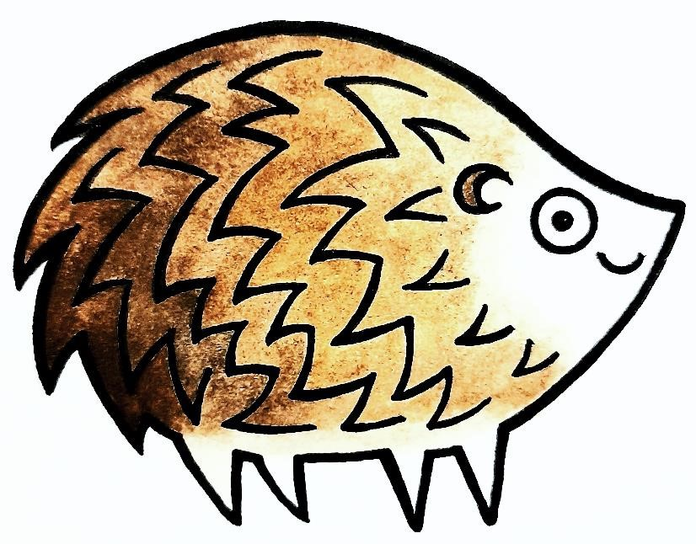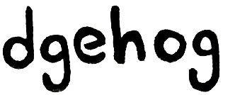"You may have read about the dilemma hedgehogs are facing due to loss of habitat.

There is an article in The Guardian about a village in Oxfordshire that has taken actions to help these special little animals.
Could How Caple Sollershope and Yatton do this?"

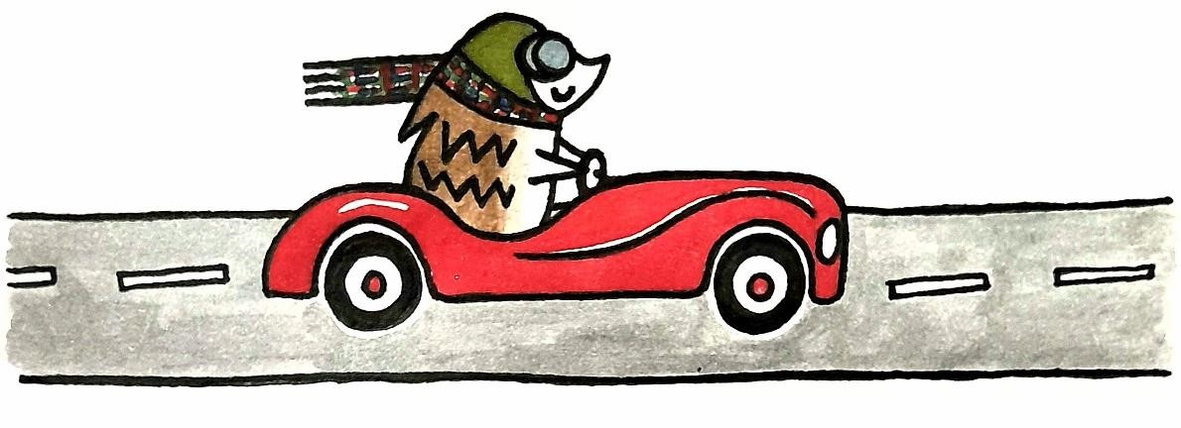
Hedgehog numbers are in decline across the UK.
In part, they are struggling because of habitat loss.
In the wild, hedgehogs can travel up to 2 miles each night, in search of a meal and a mate. With limited habitat, hedgehogs struggle to find food and produce offspring.
Save the hedgehogs!
To link up their gardens, the village of Kirtlington in
Oxfordshire has created hog-sized holes in their fences and walls. Read more about it by clicking here.
Many people across the UK have been inspired.
Keep track of the UK's hedgehog highway by clicking here.
How can we help?
If you would like to join the hedgehog highway in Fownhope, remember to check with your neighbours first!
A hedgehog hole should be 13cm and not much larger – to avoid encouraging cats, which prey on hedgehogs. There are many ways to help hedgehogs.
For ten fantastic tips, click here.

