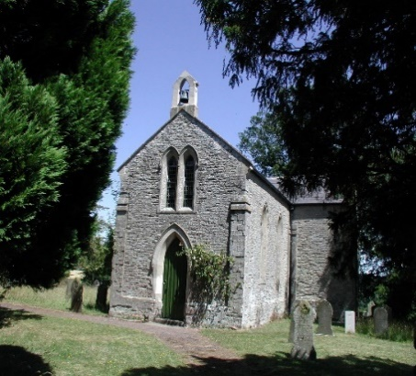  Please remember,  Hands  Face  Space  Fresh air | HOW CAPLE SOLLERSHOPE AND YATTON  GROUP PARISH COUNCIL
Your Parish Councillors are;  Yatton  Bernard Morris Chairman  Angela Hard-Bishop  Debby Clayton  Sollershope  John Jackson Vice Chairman  Barbara Cole  Liz Glover  How Caple  Chris Jones  Victor Yapp  Ward Councillor  Cllr Barry Durkin  Clerk Linda Yapp  howcapleclerk@otlook.com  01989 740240  07854 504217  Hands  Face  Space  Keeps you safe.  Herefordshire Council help lines  01432 260024  01432 260000  Forthcoming meeting dates  May 4th  July 6th  September 7th  November 2nd  8.00pm start  Parish Council Website  For information  www.  howcaplesollershopeyatton.org.uk  /parish council.  Report potholes to;  www. Herefordshire.gov.uk  and follow the link  All Covid 19 information  and latest updates also  available on this website. | Welcome to the first Parish Council Newsletter of 2021.  A very difficult few months since our last newsletter for all concerned, with the  Pandemic, Lock Down and the winter weather. But with the Vaccine speeding its way  across the country and great strides made in Herefordshire, hopefully brighter days  are on the way.  The usual goodwill from Parishioners has continued to be delivered and appreciated  In these difficult times. These include shopping for neighbours, making good untidy  and muddy lanes and continuing to communicate with Parishioners living alone.  Some delightful happy news.  Our Vice Chairman John Jackson was married to the lovely Charlotte Gregory just  before Christmas 2020. The Parish Council were fortunate to congratulate the  couple at the January meeting all good wishes were sent for their future together.  Parish Update  The main subject of conversation in the Parish and neighbouring villages has been  the problems due to the closure of the B4224. But now the road has reopened  and traffic returning to normal, I think we as a community can all sympathise with  the problems Woolhope residents encountered during the road closure.  How Caple have a smaller slippage problem on the B4224 in the area between the  Cross Roads and Cross in Hands. The Parish Council and Cllr Durkin are in  communication with Balfour Beatty who will undertake the road works and to  establish the best possible route possible for local residents to use during the repair.  Nothing has yet been finalised but a suggested date for the start of the works in the  beginning of May 2021 but no completion time has yet been agreed.  Cllr Durkin is very keen to avoid as much disruption as possible to resident and will  continue to brief the Parish Council on any progress made. We have received  information from Wye Valley AONB regarding the possibility of overhead cable being  redirected to underground in some areas. We have insufficient information at present  but will endeavour to keep you updated in the near future as to any announcement  or progress in our Parish.  Parish Councillors  The Parish Council welcomed a newly Co-opted member from Yatton at the last  Parish Council meeting. Debby Clayton is our new member and she is keen to  become involved with local issues. More about Debby in our next Newsletter.  A brief word about a Parish Councillor not yet mentioned is Victor Yapp.  Victor moved to How Caple from Mid Wales five years ago, he is a retired Engineer.  Victor’s hobbies and interest are wood working and he is a keen gardener, he has a  grown family of sons who along with his wife are all keen F.1 fans. His role  within the Parish Council is to assist with the Public Footpaths in How Caple.  Parish Council Meetings  Parish Council meetings have continued to be held Via Zoom. These have been very  successful with a good attendance from members of the public, and members would  welcome more Parishioners attending the meetings. The Zoom invitations details  are on the Parish Council website and noticeboards about five days prior to the  meetings. The clerk will also email invitations to anyone who would like to attend ,  all it needs is a call or email to the clerk for a virtual invitation.  This year the Annual Parish meeting will be a Virtual meeting at 7.30pm on May 4th  Wilmot House How Caple  Wilmot House will celebrate two years as a school boarding house this April, but  I don't think anyone could have predicted the turbulent experiences of the past  twelve months! The students and staff acknowledge how fortunate they are to live  in such a magnificent building in the beautiful Herefordshire countryside. The building  was refurbished to a very high standard and now offers accommodation for up  to 29 students. Former Hereford Cathedral School pupil and How Caple resident  Verity Coleman is credited with the amazing interior décor.  As a home for mainly international students, they have experienced a challenging  twelve months. Some students have been unable to return to their families as some  have managed to fly home but been unable to return There are currently only nine  students in residence and a similar number joining lessons remotely from China  and Hong Kong, often in the middle of their night. There are signs of a recovery in  student numbers already for the September term.  During this challenging year all students and residents at Wilmot House are grateful  to be in such an idyllic spot.  Local Elections  The Police and Crime Commissioners elections will be held at the Parish Hall in  Brockhampton on the 6th May observing social distancing and the wearing of masks.  Ash Die Back  We are fortunate to have John Jackson on our team as John has expert knowledge in  the wellbeing and problems with our native trees. John reported at the last Parish  Council meeting the concerns in the locality with Ash Die back and for resident to be  aware of this.  Future Newsletters.  As we all become more and more in tune with the world of technology if you would  prefer to receive your Parish Newsletter by email please let our clerk know,  send your email address to the clerk will put you on the mailing list.

